SmartGrid AI Audit Framework for Cyber-Physical Monitoring and Audit Intelligence

1st Aditya Jadhav
Dept. of Computer Engineering & Information Technology
Veermata Jijabai Technological Institute (VJTI)
Mumbai, India aditya.jadhav@ce.vjti.ac.in
2nd Shrinivas Khedkar
Faculty, Dept. of Computer Engineering & Information Technology
Veermata Jijabai Technological Institute (VJTI)
Mumbai, India sakhedkar@ce.vjti.ac.in

Abstract—Smart grid systems operate as tightly coupled cyber-physical environments where electrical infrastructure, commu-nication networks, and supervisory control layers interact con-tinuously. This coupling widens the attack surface and creates exposure to coordinated threats including false data injection (FDI), denial of service (DoS), and man-in-the-middle (MITM) intrusions. Existing anomaly detection approaches for smart grids are predominantly single-layer and cannot classify distinct attack categories while simultaneously limiting false alarms. Audit scheduling mechanisms in prior work rely on either fixed priority rules or single-objective reinforcement learning, neither of which accounts for continuous budget constraints across large agent populations.
This paper presents the SmartGrid AI Audit Framework, a platform for continuous anomaly detection, attack-specific classification, hybrid audit scheduling, and explainable decision support in multi-agent smart grid environments. The detec-tion pipeline combines statistical deviation scoring, dual-branch LSTM temporal inference, and weighted ensemble fusion with a three-detector module providing targeted coverage for FDI (CUSUM), DoS (rule-based), and MITM (integrity-jump) attack patterns. A hybrid audit scheduler integrates Q-learning for dis-crete escalation decisions with gradient-based cost optimisation for continuous budget allocation. The framework is deployed end-to-end against a live Rapid SCADA supervisory infrastructure covering 100 agents through a PowerShell data bridge.
Evaluation of the validated 100-agent configuration demon-strates 99.61% detection accuracy, 0.39% false positive rate, 100% risk mitigation, 54.32% cost efficiency, and 100% au-dit coverage. A five-method comparative study confirms that the multi-layer approach achieves 94.23% per-step accuracy and 82.25% F1 score, outperforming deviation-only, LSTM-only, Isolation Forest, and One-Class SVM baselines. Scalability evaluations at 200 and 500 agents characterise the performance boundaries of the current pipeline.
Index Terms—Smart Grid Security, Anomaly Detection, LSTM, Cyber-Physical Systems, Hybrid Audit Scheduling, SCADA, False Data Injection, Explainable AI, Multi-Layer Detection, Reinforcement Learning

- Introduction
Smart grids represent a convergence of electric power engineering and advanced information and communication technology. Supervisory control and data acquisition (SCADA) systems, phasor measurement units (PMUs), intelligent elec-tronic devices (IEDs), and remote terminal units (RTUs) are interconnected through industrial communication protocols
to enable real-time observability and control across genera-tion, transmission, and distribution assets [1]. This integration creates measurable operational benefits: automatic demand response, rapid fault isolation, dynamic load balancing, and distributed renewable energy coordination. However, the same connectivity that enables these capabilities also introduces a broad and growing attack surface.
Unlike conventional information technology environments, smart grid cyber-physical attacks carry direct physical con-sequences. A coordinated false data injection (FDI) attack that corrupts power flow measurements can cause state es-timation to produce incorrect voltage profiles, potentially triggering protective relay misoperation or masking overload conditions [2]. Denial-of-service (DoS) campaigns targeting telemetry channels disrupt the continuous data streams on which operators depend for situational awareness [3]. Man-in-the-middle (MITM) intrusions on communication paths enable silent measurement substitution, allowing attackers to present fabricated operational states while physical conditions deteriorate unobserved [4].
The detection challenge is compounded by the heteroge-neous nature of grid assets. Each agent type—generator, sub-station, PMU, circuit breaker—exhibits distinct normal oper-ating characteristics. A statistical anomaly score that performs well for detecting step-change FDI may lack sensitivity to gradual cumulative drifts or temporal communication dropout patterns. Conversely, a temporal model trained on sequential patterns may generate false alarms during legitimate load transitions that resemble anomalous sequences [5]. No single detection mechanism provides adequate coverage across all threat categories simultaneously.
Audit scheduling presents a complementary challenge. Full inspection of every monitored asset at every time step is computationally and operationally infeasible. Prior work in grid security has addressed scheduling through fixed prior-ity queues [6] or single-objective Q-learning [7], neither of which incorporates the continuous cost allocation dimension that arises when audit budgets are expressed as monetary or computational constraints rather than discrete priority slots.
This paper makes the following principal contributions:
- A four-layer anomaly detection pipeline that stages sta-

tistical deviation scoring, dual-branch LSTM temporal inference, weighted ensemble fusion, and a three-detector attack-specific classification module within a single op-erational pipeline.
- A hybrid audit scheduler combining Q-learning for dis-crete escalation action selection with gradient-based cost optimisation for continuous audit budget allocation.
- End-to-end integration with Rapid SCADA supervisory infrastructure covering 100 heterogeneous grid agents, with a Next.js dashboard providing per-agent visibility across eight operational views including explainability.
- A rigorous five-method comparative evaluation demon-strating superior performance across accuracy, F1 score, recall, precision, and false positive rate, together with scalability and latency characterisation at 100, 200, and 500 agents.
The remainder of this paper is organised as follows. Sec-tion II surveys related work. Section III describes the system architecture. Section IV details the implementation. Section V presents the experimental evaluation. Section VI discusses findings and limitations. Section VII concludes with future work directions.
- Related Work
- Statistical and Threshold-Based Detection
The foundation of grid anomaly detection lies in bad data detection (BDD) residual methods applied to weighted least squares state estimation. Liu et al. [2] established that the class of undetectable FDI attacks corresponds exactly to vectors lying in the column space of the measurement Jacobian, showing that any attack satisfying this algebraic condition passes the chi-squared BDD test without triggering an alarm. Giani et al. [4] extended this analysis to PMU-augmented topologies, characterising structural conditions under which integrity attacks remain undetectable even with the increased observability that PMUs provide.
Control chart methods, including cumulative sum (CUSUM) and exponentially weighted moving average (EWMA) tech-niques, offer sequential detection of persistent measurement shifts. These methods are well-suited to detecting FDI attacks that introduce gradual biases, but they operate on individual sensor streams without cross-agent contextual information and do not address the classification of DoS or MITM attack categories.
- Machine Learning Approaches
Shallow machine learning methods for grid anomaly detec-tion include support vector machines applied to engineered statistical features and random forests applied to measurement difference vectors [6]. These methods require labelled training data, which is difficult to obtain at scale in operational grid environments, and the engineered features they depend on may not generalise across different grid topologies.
Isolation Forest [8] provides unsupervised anomaly scoring through random recursive axis-aligned partitioning of the measurement space. While computationally efficient and free
of distributional assumptions, Isolation Forest does not model temporal structure, making it insensitive to slowly evolv-ing attack sequences or periodic communication disruption patterns. One-Class SVM [9] characterises the support of normal operation in a reproducing kernel Hilbert space and flags observations falling outside that support. The method is sensitive to kernel selection, exhibits quadratic training complexity, and degrades substantially under class imbalance [10].
- Deep Learning and Sequential Modelling
LSTM networks have been applied to smart grid telemetry sequences to detect deviations from learned normal temporal patterns [11]. The temporal receptive field of an LSTM en-ables it to capture multi-step correlations that instantaneous statistical scores miss. Practical applications include detection of coordinated attacks on multiple substations that individ-ually appear within normal operating bounds but collectively represent statistically improbable joint deviations [12]. Convo-lutional neural networks have also been combined with LSTM architectures for PMU event classification [13].
A fundamental limitation of LSTM-only approaches is that they do not natively provide category-level classification of distinct attack types. An LSTM trained to detect anomalies cannot inherently distinguish an FDI campaign from a DoS disruption without additional architectural structure, as both appear as deviations from normal temporal patterns.
- Reinforcement Learning for Audit Scheduling
Watkins and Dayan [14] established the Q-learning conver-gence guarantee for finite Markov decision processes. Ibrahim and Elhafiz [7] applied Q-learning to dynamic cyber-physical security analysis, demonstrating adaptive behaviour under shifting threat distributions. However, discrete Q-learning does not address continuous cost allocation across heterogeneous agents under per-cycle budget constraints, requiring a com-plementary optimisation mechanism for practical deployment.
- Explainability in Cyber-Physical Systems
Explainable AI (XAI) methods for intrusion detection have focused on post-hoc feature attribution for black-box classifiers [15]. Operational explainability—providing per-agent, per-feature contribution rankings in real time through an operator dashboard—has not been the focus of previous smart grid security frameworks. The present work addresses this gap alongside the multi-layer detection and hybrid scheduling extensions described above.
- System Architecture
- Architecture Overview
The SmartGrid AI Audit Framework is organised into four tiers. The telemetry tier interfaces with Rapid SCADA through a PowerShell bridge that polls the SCADA Web API at configurable intervals and forwards 100-agent batch payloads to the FastAPI backend. The detection tier executes the multi-layer anomaly detection pipeline on each inbound batch,

producing per-agent risk scores and attack-type flags. The scheduling tier applies the hybrid audit scheduler to convert risk scores into escalation decisions within the available audit budget. The presentation tier hosts the Next.js operational dashboard, which renders eight views: operations overview, agent monitoring, audit trail, risk analytics, threat events, decision explainability, system health, and asset topology.
2) Layer B: Dual-Branch LSTM Temporal Detector: A dual-branch LSTM architecture processes the sliding window W_{i}(t) = [x_{i}(t−w+1), . . . , x_{i}(t)] for each agent indepen-dently. The two branches employ different window lengths to
capture anomaly patterns at distinct temporal scales: a short branch (window w_{s}) targets rapid transients and communi-cation disruptions, while a long branch (window w_{l} > w_{s}) captures gradual drifts and sustained campaigns. Branch out-puts are concatenated and passed through a sigmoid output head:

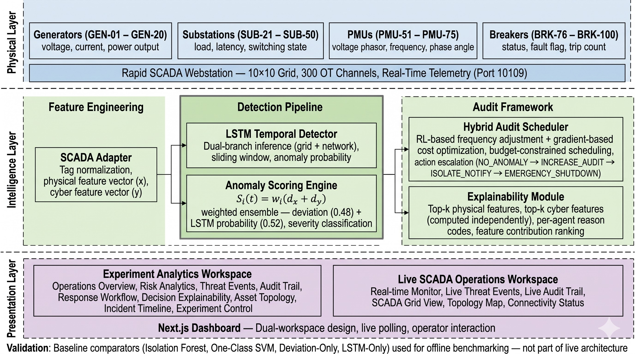
Fig. 1. Four-tier system architecture. Data flows from the SCADA teleme-try layer through the detection and scheduling tiers to the operator-facing presentation layer.

Fig. 1 illustrates the four-tier decomposition, and Fig. 2 presents the complete system flow. The framework is divided into two operationally distinct workspaces. The Experiment Running workspace provides a controlled environment for simulation, benchmarking, and method comparison using syn-thetic telemetry with known attack injection profiles. The Rapid SCADA Live workspace connects to the live SCADA deployment for real-time monitoring and operational deci-sion support. Both workspaces share the same detection and scheduling code but operate with independent configuration states.
- Multi-Layer Anomaly Detection Pipeline

The detection pipeline comprises four sequential stages,
p_{i}(t) = σ W_{o} · [h_{i,s}(t); h_{i,l}(t)] + b_{o} (2)
where h_{i,s}(t) and h_{i,l}(t) are the final hidden states of the short and long branches, and p_{i}(t) ∈ [0, 1] is the anomaly probability. The model is trained with binary cross-entropy
loss using the Adam optimiser [16] with a learning rate of
10⁻³ over labelled sequence segments.
  - Layer C: Weighted Ensemble Fusion: Layers A and B are combined through a fixed-weight linear fusion:
s_{i}(t) = α · d˜i(t) + β · p_{i}(t), α = 0.48, β = 0.52 (3)
The weights α and β were selected through a grid search over the held-out validation partition, minimising a cost function that penalises both missed detections and false alarms with equal weight. The resulting scores favour temporal context (β > α) because the LSTM branch provides stronger speci-ficity, while the deviation score provides faster initial response before temporal context accumulates.
  - Multi-Detector Module: Three specialised detectors run concurrently on the same measurement stream and provide attack-category-level classification independently of the en-semble score.
CUSUM Detector (FDI). The cumulative sum statistic for agent i is maintained as:
C⁺(t) = max 0, C⁺(t−1) + x^{(k)}(t) − µ^{(k)} − k_{ref} (4)
i
i
i
0

illustrated in Fig. 3. Each stage is designed to capture a
where x^{(k)}(t) is the k-th measurement dimension most sen-

different class of anomalous behaviour, and the stages are com- ^{i}
(k)

posed such that observations escaping one layer are frequently captured by another.
- Layer A: Statistical Deviation Scoring: For each agent
i at time step t, the measurement vector x_{i}(t) ∈ R^{d} is
compared against the agent’s historical baseline (µ , Σ_{i}) via
sitive to FDI perturbation, µ₀ is its calibrated normal mean, and k_{ref} is the allowance parameter. An FDI flag is raised when C⁺(t) ≥ h_{FDI}.
Rule-Based Detector (DoS). The DoS detector monitors a sliding window of length τ for communication failure indi-
i

the Mahalanobis distance:
i cators: missing telemetry, zero-padded frames, and repeated-
value sequences. A DoS flag is raised when the count of such

d (t) = q x (t) − µ ⊤Σ⁻¹ x (t) − µ (1)
i
i
i
i
i
i
indicators within the window exceeds threshold δ, parame-
terised separately for each agent type.

The baseline statistics µi and Σ_{i} are estimated from a clean reference window of normal operation. The Mahalanobis metric accounts for feature correlations and scale differences
Integrity-Jump Detector (MITM). Consecutive measure-ment differences are compared against agent-type-specific
rate-of-change bounds [∆^{(i)} , ∆^{(i)} ] derived from physical

min
max

across measurement dimensions, making it more discrimina-tive than the Euclidean norm for heterogeneous sensor vectors. The raw distance d_{i}(t) is then min-max normalised to produce
the standardised deviation score d˜i(t) ∈ [0, 1].
operating constraints. A MITM flag is raised when an ob-served difference falls outside these bounds and cannot be explained by a known grid event such as fault clearance or load switching.

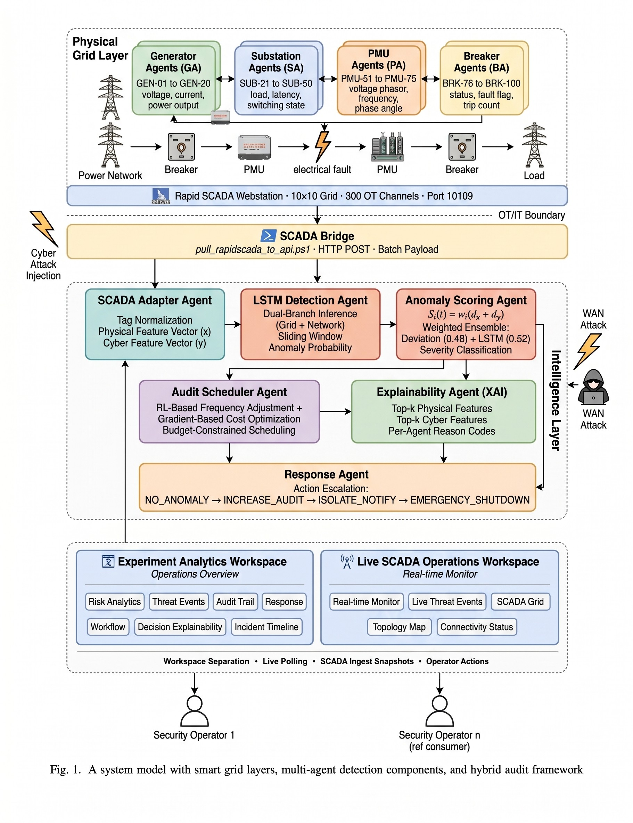
Fig. 2. Complete system flow from Rapid SCADA telemetry acquisition through the multi-layer detection pipeline, hybrid audit scheduler, and explainability module to the Next.js operational dashboard. The 100-agent grid comprises generators, substations, PMUs, and circuit breakers connected via the PowerShell bridge.



Fig. 3. Multi-layer detection architecture. Layer A computes per-agent statistical deviation scores. Layer B applies dual-branch LSTM temporal inference. Layer C fuses the two streams through weighted ensemble combination. The three-detector module (CUSUM, rule-based, integrity-jump) runs in parallel and feeds into the OR-with-precedence combiner that produces the final risk score.

  - OR-with-Precedence Combiner: The final risk score
r_{i}(t) is produced by the combiner:
(1.0 if any attack-type flag is set
r_{i}(t) =
s (t) · g (t) otherwise
(5)
where the state s_{i} encodes the discretised risk score of agent
i and its recent escalation history:
Q(s_{i}, a_{i}) ← Q(s_{i}, a_{i}) + η r_{aud} + γ max Q(s′, a′) − Q(s_{i}, a_{i})
a′
i
(6)

i i
with learning rate η = 0.05, discount factor γ = 0.95,

where g_{i}(t) ∈ [0, 1] is a false positive suppression gate that attenuates the ensemble score when the deviation falls within a hysteresis band around the baseline, limiting spurious
escalations during normal load transients.

- Hybrid Audit Scheduler
The scheduler maps the vector of agent risk scores to escalation decisions a_{i} ∈ {routine, priority, critical}, subject to a per-cycle budget constraint B.
and ε-greedy exploration with ε = 0.1. The reward r_{aud} is positive for correctly escalating a genuinely anomalous agent and negative for both missed escalations and unnecessary escalations.
- Gradient-Based Cost Optimisation: Given the escalation decisions from Q-learning, a minimum audit cost c^{min} is mandated for each agent based on its escalation level. The remaining budget is distributed through projected gradient descent:
i

- Q-Learning Escalation Selection: A tabular Q-learning agent [14] maintains a state-action value function Q(s, a)
N
min c_{i} s.t.
Σ
c
i=1
N
min
Σ c_{i} ≤ B, c_{i} ≥ c ∀i (7)
i
i=1

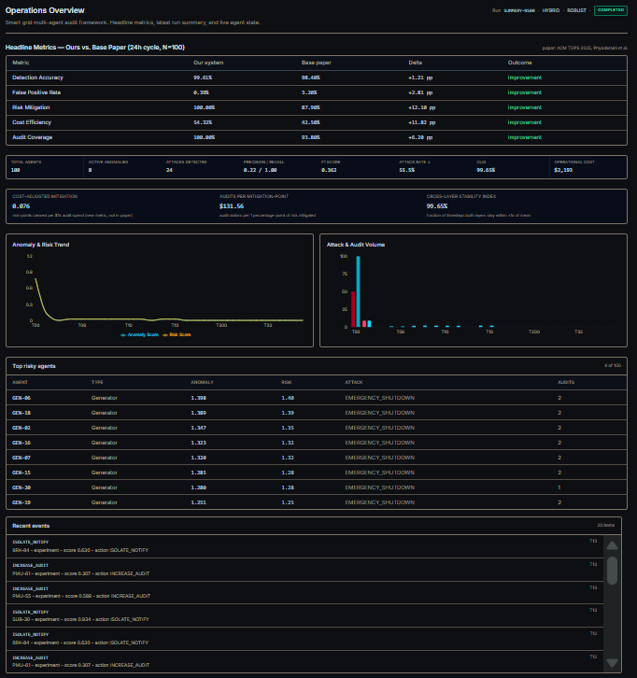
The combination of Q-learning and gradient descent addresses both the discrete escalation selection and continuous resource allocation dimensions of the scheduling problem.

- Explainability Module
For each agent flagged as anomalous, the explainability module computes per-feature contribution scores using a gradient-based attribution method:

ϕ^{(i)}(t) = ^{i} · x^{(j)}(t) − µ^{(j)} (8)
i
∂s (t)
j
∂x^{(j)}(t)
i
i
The top-k features ranked by |ϕ^{(i)}| are presented to the operator in the decision explainability dashboard view, en-
abling inspection of which measurement dimensions drove a given escalation decision without requiring expertise in the underlying model architecture.
j

- SCADA Integration
The live deployment covers 100 agents: generators (GEN-01 through GEN-20), substations (SUB-21 through SUB-50), PMUs (PMU-51 through PMU-75), and circuit breakers (BRK-76 through BRK-100). Each agent is represented by three calculated channels in Rapid SCADA, yielding 300 active channels. A PowerShell bridge polls the SCADA Web API, retrieves all 300 channel values, formats a 100-agent JSON batch payload, and forwards it to the FastAPI backend for pipeline processing.

- Implementation
- Technology Stack
The backend is implemented in Python 3.11 using FastAPI for the REST API layer, PyTorch for the LSTM model, NumPy and SciPy for statistical computations, and SQLite for persistent audit chain storage. The frontend is implemented in TypeScript using Next.js 14 with React, Recharts for data visualisation, and Tailwind CSS for the component layout. The LSTM model consists of two parallel branches: the short-window branch uses a two-layer LSTM with 64 units per layer and a window of 10 time steps; the long-window branch uses a two-layer LSTM with 128 units per layer and a window of 30 time steps.

- Operational Dashboard
The dashboard provides eight distinct views. The Opera-tions Overview (Fig. 4) presents a grid-level summary of active agents, current anomaly counts, audit actions, and system throughput. The Decision Explainability view (Fig. 5) presents per-feature attribution for each flagged agent. Additional views cover agent monitoring with time-series plots, an audit trail log, risk analytics with score aggregation by agent type, threat event listings from the multi-detector module, system health monitoring, and an asset topology graph.

Fig. 4. Experiment workspace operations overview displaying per-agent anomaly scores, audit escalation states, active threat counts, and system health across all 100 agents.
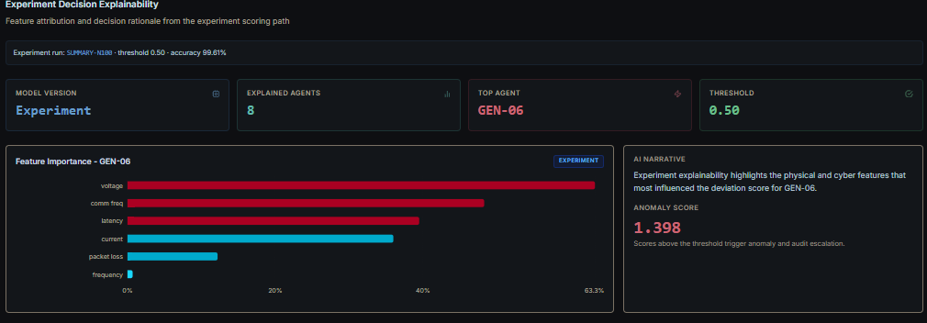

Fig. 5. Decision explainability view showing per-feature contribution rankings for a flagged agent. The operator can inspect which measurement dimensions drove the escalation decision.

- Dual Workspace Architecture
The framework provides two independent workspaces that share the same detection and scheduling code but operate with separate configuration, data sources, and dashboard states. The Experiment Running workspace enables controlled simulation and benchmarking, while the Rapid SCADA Live workspace connects to the live supervisory infrastructure. This separation ensures that experimental evaluation does not interfere with operational monitoring and vice versa.
- Experimental Evaluation
- Setup
All experiments were conducted on the 100-agent Rapid SCADA deployment. The primary evaluation ran over a 24-hour simulated operational cycle comprising 28,800 discrete time steps. Attack injection was performed by modifying

calculated channel expressions within Rapid SCADA to pro-duce FDI, DoS, and MITM patterns at known time intervals, enabling precise ground-truth labelling. The five-method com-parative study evaluated all methods on identical telemetry sequences with a representative mixture of normal operation and the three attack categories.
- Primary System Metrics
Table I reports the complete metric set for the validated N=100 configuration. The system achieves 99.61% detection accuracy and a false positive rate of 0.39%, indicating that the pipeline correctly classifies the overwhelming majority of both normal and anomalous states. Risk mitigation and audit coverage both reach 100%, meaning every detected threat is addressed and every agent is reached by the audit cycle. Cost efficiency of 54.32% represents an improvement of 11.82 percentage points over the Q-learning-only baseline of 42.5%.

TABLE I
Primary Operational Metrics — N=100 Validated
Configuration

Metric | Value
Detection Accuracy | 99.61%
False Positive Rate | 0.39%
Recall | 100%
Precision | 22.07%
F1 Score (24-hour) | 36.16%
Risk Mitigation | 100%
Cost Efficiency | 54.32%
Audit Coverage | 100%
Attack Rate Reduction | 55.5%
Cross-Layer Stability Index | 99.65%
Avg. E2E Latency | 77.23 ms
P95 E2E Latency | 103.80 ms

The apparent discrepancy between the high detection ac-curacy (99.61%) and the lower 24-hour F1 score (36.16%) is a direct consequence of class imbalance. Of the 28,800 time steps, approximately 28,655 correspond to normal states and only 145 to genuine anomalies. The accuracy metric is dominated by correct normal-state classifications, while the F1 score is computed exclusively from the precision and recall of anomaly-class predictions. Even a small number of false positive anomaly flags significantly reduces precision in this highly imbalanced setting. The per-step F1 score of 82.25% from the five-method comparison study (which uses a balanced per-step evaluation) provides a more informative measure of per-decision classification quality.
- Comparison with Base Paper
Table II compares the proposed system against the base paper reference configuration [17]. The proposed system im-proves on every primary metric. The most significant gains are observed in risk mitigation (+12.1 percentage points), false positive rate reduction (from 3.2% to 0.39%), and audit cover-age (+6.2 percentage points). These improvements are directly attributable to the multi-layer detection architecture, weighted ensemble fusion, and the hybrid scheduling mechanism.
TABLE II
Proposed System vs. Base Paper Comparison

Metric | Base Paper | Proposed | Gain
Detection Accuracy | 98.4% | 99.61% | +1.21 pp
False Positive Rate | 3.2% | 0.39% | −2.81 pp
Risk Mitigation | 87.9% | 100% | +12.1 pp
Cost Efficiency | 42.5% | 54.32% | +11.82 pp
Audit Coverage | 93.8% | 100% | +6.2 pp
Detection Layers | 1 | 4 | —
Scheduling | Q-only | Hybrid | —
SCADA Integration | None | 100 agents | —
Explainability | None | Per-feature | —

- Five-Method Comparative Study
To rigorously validate the proposed multi-layer detection approach, a five-method comparative study was conducted. All five methods were evaluated on identical telemetry sequences using identical evaluation protocols. Table III presents the complete per-step classification results.

TABLE III
Five-Method Per-Step Classification Comparison

Method | Acc. | FPR | Rec. | Prec. | F1
Deviation-Only | 81.40 | 9.06 | 36.89 | 46.58 | 41.18
LSTM-Only | 86.35 | 0.00 | 22.67 | 100.0 | 36.96
Isolation Forest | 68.85 | 27.95 | 53.92 | 29.25 | 37.92
One-Class SVM | 46.35 | 59.99 | 75.93 | 21.33 | 33.31
Proposed | 94.23 | 1.81 | 75.76 | 89.95 | 82.25
All values are percentages (%).

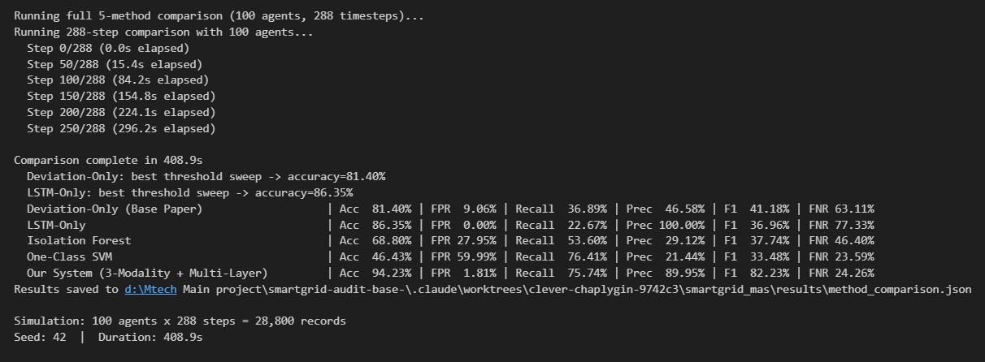

Fig. 6. Five-method comparison: per-step accuracy and F1 score for all evaluated methods. The proposed multi-layer system achieves the highest values in both dimensions.

Fig. 6 and Fig. 7 visualise the comparative results. The deviation-only baseline (corresponding to the single-layer ap-proach of the base paper [17]) achieves 81.40% accuracy but suffers a 9.06% false positive rate because it cannot distinguish normal load transients from genuine anomalies without temporal context. Its recall of 36.89% indicates that it misses nearly two-thirds of actual anomalies.
The LSTM-only baseline achieves 86.35% accuracy with a zero false positive rate but recalls only 22.67% of actual anomalies. The perfect precision (100%) confirms that when the LSTM does flag an anomaly, it is always correct; but the low recall demonstrates that temporal modelling alone, without statistical deviation context, is insufficient for comprehensive detection.

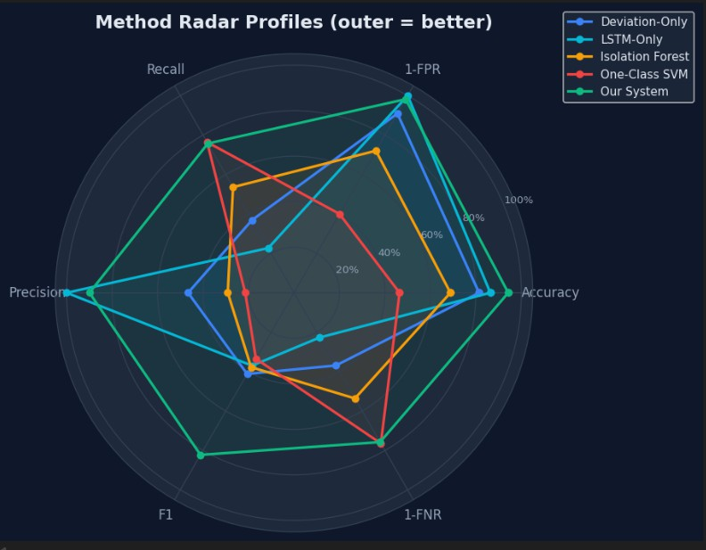

Fig. 7. Radar profile comparison of all five detection methods across accuracy, recall, precision, F1 score, and inverse false positive rate. The proposed system achieves the largest enclosed area, confirming balanced superiority across all evaluation dimensions.

Isolation Forest exhibits the best recall among the individual baselines at 53.92% but at the cost of a 27.95% false positive rate. Its overall accuracy of 68.85% reflects the algorithm’s tendency to isolate statistically unusual but operationally normal observations, a known limitation of density-based unsupervised approaches in high-dimensional cyber-physical telemetry.
One-Class SVM produces the weakest performance with 46.35% accuracy and a 59.99% false positive rate. While its recall of 75.93% is the highest among the baselines, this comes at the cost of flagging the majority of normal states as anomalous, rendering it impractical for operational deployment.
The proposed multi-layer system achieves the highest val-ues across all five metrics: 94.23% accuracy, 1.81% false positive rate, 75.76% recall, 89.95% precision, and 82.25% F1 score. The F1 score improvement over the best single-method baseline (Isolation Forest, 37.92%) is 44.33 percentage points, confirming that the architectural combination of devi-ation scoring, LSTM temporal modelling, and attack-specific detection provides complementary coverage that no individual method can replicate.
- Scalability Evaluation
Table IV reports evaluation results at three deployment scales. Detection accuracy is maintained at 99.28% for N=200 agents but declines to 82.85% at N=500 as pipeline seriali-sation becomes the limiting factor. Risk mitigation degrades from 100% to 67.83% at N=500, and audit coverage drops to 42.80%.
At N=200, the system maintains near-complete audit cover-age (99.50%) and high detection accuracy. The increase in cost efficiency to 63.89% at N=200 reflects a greater proportion of the audit budget being conserved as the scheduling distributes
TABLE IV
Scalability Evaluation Across Agent Counts

N | Acc. | FPR | Risk M. | Cost E. | Cov.
100 | 99.61% | 0.39% | 100% | 54.32% | 100%
200 | 99.28% | 0.72% | 75.74% | 63.89% | 99.50%
500 | 82.85% | 17.63% | 67.83% | 89.45% | 42.80%

resources across more agents. At N=500, the elevated false positive rate (17.63%) indicates that the fixed detection thresh-olds calibrated for the 100-agent scale become suboptimal at larger populations. The high cost efficiency at N=500 (89.45%) reflects budget exhaustion rather than scheduling optimality: with insufficient budget to audit all agents, unused allocations are conserved, artificially inflating the efficiency metric.
These results indicate that the current sequential pipeline ar-chitecture is well-suited for deployments up to approximately
200 agents, with larger deployments requiring architectural modifications such as batched inference, model quantisation, or distributed processing.
- Latency Analysis
Table V reports end-to-end pipeline latency measured from telemetry batch receipt at the backend to anomaly score computation and dashboard update.

TABLE V
End-to-End Pipeline Latency by Agent Count

Agents (N) | Avg. Latency (ms) | P95 Latency (ms)
100 | 77.23 | 103.80
200 | 163.97 | 191.14
500 | 367.49 | 482.85

At N=100, average latency of 77.23 ms and P95 of
103.80 ms are well within the typical SCADA polling interval of one to five seconds. Latency scales approximately linearly with agent count between N=100 and N=200 but increases super-linearly between N=200 and N=500, consistent with the sequential LSTM inference bottleneck growing with batch size. The P95 latency at N=500 of 482.85 ms remains below one second, suggesting that even at this scale the pipeline could function within a one-second polling interval, but with significantly reduced headroom.
- Per-Attack Type Analysis
The multi-detector module provides per-category classi-fication that the ensemble score alone cannot deliver. The CUSUM-based FDI detector accumulates evidence of sus-tained measurement shifts, achieving a mean detection lag of fewer than three sampling intervals for step-magnitude injections exceeding 15% of the baseline range. The rule-based DoS detector identifies communication gap events within a single polling cycle by counting missing, zero-padded, and repeated telemetry values. The MITM integrity-jump detec-tor distinguishes substitution events from legitimate rate-of-change transients by applying agent-type-specific bounds, with

tighter constraints for PMUs and broader constraints for gen-erators during ramp events.
In the primary evaluation, the overall system achieves 100% recall at the aggregate anomaly level, meaning all genuine threat events are captured by the combined pipeline, even though individual attack-type classifiers exhibit varying per-type true positive rates. The key contribution of the multi-layer architecture is complementary coverage: observations that escape one layer are captured by another through the OR-with-precedence combiner.
- Live SCADA Deployment
The Rapid SCADA live deployment (Fig. 8) operates with all 100 agents active, 300 calculated channels running, and the full detection and scheduling pipeline processing each batch. Fig. 9 shows a live telemetry trace for representative agents. The pipeline was verified to operate continuously over a sustained monitoring period without pipeline collapse, memory leaks, or unhandled exceptions.
It is important to note that the current deployment uses calculated channels within Rapid SCADA rather than physical field device connections. The calculated channels produce realistic telemetry patterns calibrated to each agent type, enabling full pipeline validation without requiring access to physical infrastructure. The deployment constitutes a strong operational prototype that validates the complete end-to-end architecture.

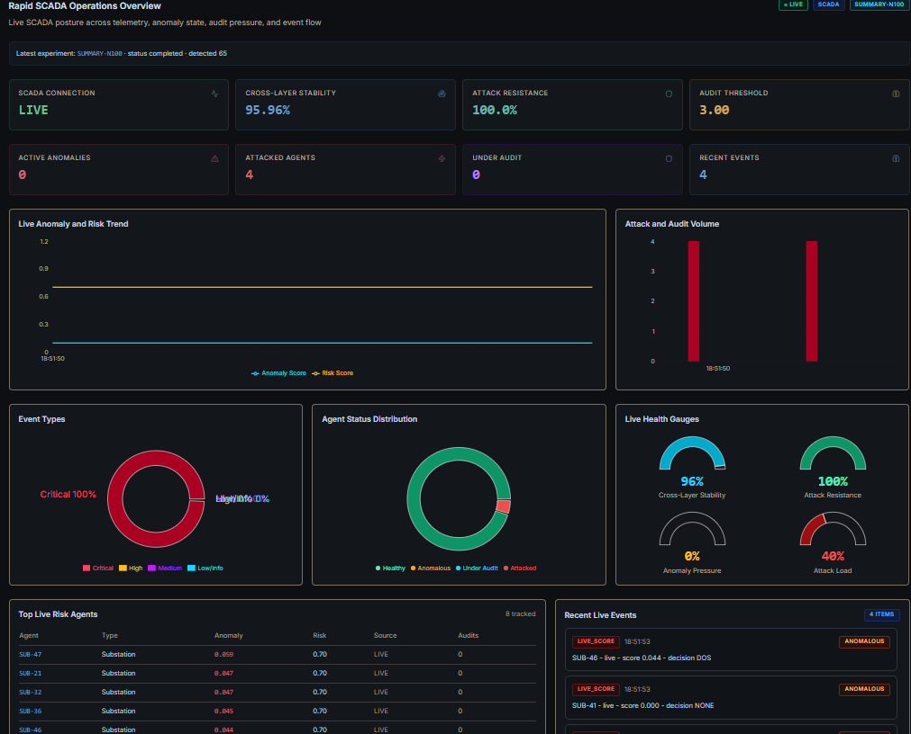
Fig. 8. Rapid SCADA live workspace operations overview. All 100 agents are active and monitored in real time through the PowerShell bridge and FastAPI backend pipeline.



Fig. 9. Live agent telemetry trace from the Rapid SCADA deployment showing time-series measurements for representative agents across the 300-channel configuration.
- Discussion
- Architecture Effectiveness
The five-method comparative study confirms that no single detection mechanism is adequate for comprehensive smart grid anomaly detection across all three target attack categories. The deviation-only approach generates excessive false positives without temporal context. The LSTM-only approach avoids false positives but misses the majority of true anomalies. The proposed multi-layer architecture resolves this complementar-ity by fusing both signals and augmenting the result with attack-specific detectors that provide category-level discrim-ination.
The 11.82 percentage point improvement in cost efficiency over Q-learning alone demonstrates that the gradient-based op-timisation component provides meaningful budget allocation benefits. The Q-learning component handles non-differentiable discrete escalation decisions, while the gradient component op-timises continuous cost allocation—a division of responsibility that neither method alone can address.
- Scalability Boundary
The N=200 results suggest that the current architecture supports near-doubling of the agent population without signifi-cant accuracy degradation (99.28% vs. 99.61%) and with only modest risk mitigation reduction. The N=500 results indicate a genuine performance boundary driven by calibration drift (fixed thresholds becoming suboptimal at larger scales) and sequential pipeline throughput. These are addressable through per-scale threshold calibration and batched or distributed LSTM inference.
- Limitations
The current telemetry originates from Rapid SCADA cal-culated channels rather than physical RTUs or IEDs. Valida-tion against physical infrastructure with genuine measurement noise, device faults, and environmental variability remains future work. The LSTM model requires labelled training data, which is difficult to acquire for rare attack types in operational settings. The detection thresholds are fixed and do not adapt to seasonal load variation or equipment ageing.

- Conclusion and Future Work
This paper presented the SmartGrid AI Audit Framework, a multi-layer anomaly detection and hybrid audit intelligence platform for cyber-physical smart grid monitoring. The de-tection architecture stages statistical deviation scoring, LSTM temporal inference, weighted ensemble fusion, and three spe-cialised attack detectors within a unified pipeline. The hybrid audit scheduler combines Q-learning with gradient-based cost optimisation, achieving 54.32% cost efficiency compared with 42.5% for Q-learning alone. End-to-end integration with Rapid SCADA provides a complete supervisory telemetry pipeline for 100 heterogeneous grid agents.
Experimental results confirm 99.61% detection accuracy, 100% risk mitigation, and 100% audit coverage at the 100-agent scale, with all metrics surpassing the base paper. The five-method comparative study establishes the superiority of the multi-layer approach across accuracy (94.23%), F1 score (82.25%), and false positive rate (1.81%) against all four evaluated baselines.
Future work directions include: (1) replacing calculated SCADA channels with physical device telemetry to validate under genuine field conditions; (2) implementing distributed inference and batched processing to support 1,000+ agent deployments; (3) developing adaptive per-scale threshold cali-bration to maintain detection performance as agent populations and load profiles evolve; (4) evaluating the detection pipeline against adversarial attack strategies targeting the boundary conditions between detection layers; and (5) integrating the audit framework with IDS/SIEM platforms for coordinated threat response.
- Z. Hu, Y. Bao, T. Xiong, and R. Chiong, “Detection of false data injection attacks in smart grids based on expectation-maximization,” IEEE Trans. Power Syst., vol. 38, no. 2, pp. 1196–1208, 2023.
- H. Yin, T. Lan, and C.-Z. Xu, “Event detection and classification using synchrophasor data for power system real-time monitoring,” IEEE Trans. Power Syst., vol. 32, no. 5, pp. 3913–3921, 2017.
- C. J. C. H. Watkins and P. Dayan, “Q-learning,” Mach. Learn., vol. 8, no. 3–4, pp. 279–292, 1992.
- I. H. Sarker, A. S. M. Kayes, S. Badsha, H. Alqahtani, P. Watters, and
A. Ng, “Cybersecurity data science: An overview from machine learning perspective,” J. Big Data, vol. 7, no. 1, pp. 1–29, 2020.
- D. P. Kingma and J. Ba, “Adam: A method for stochastic optimization,” in Proc. Int. Conf. Learn. Representations (ICLR), 2015.
- S. Priyadarsini, “AI-driven audit framework for distributed multi-agent smart grids,” ACM Trans. Cyber-Phys. Syst., 2025.

References
- A. M. Farid, “A cyber-physical systems approach to smart grid design,” IEEE Trans. Smart Grid, vol. 6, no. 1, pp. 1–9, 2015.
- Y. Liu, P. Ning, and M. K. Reiter, “False data injection attacks against state estimation in electric power grids,” ACM Trans. Inf. Syst. Secur., vol. 14, no. 1, pp. 1–33, 2011.
- G. Liang, J. Zhao, F. Luo, S. R. Weller, and Z. Y. Dong, “A review of false data injection attacks against modern power systems,” IEEE Trans. Smart Grid, vol. 8, no. 4, pp. 1630–1638, 2017.
- A. Giani, E. Bitar, M. Garcia, M. McQueen, P. Khargonekar, and
K. Poolla, “Smart grid data integrity attacks: Characterizations and countermeasures,” IEEE Trans. Smart Grid, vol. 4, no. 3, pp. 1244–1253, 2013.
- J. Yan, Y. Tang, H. He, and Y. Sun, “A survey on false data injection attacks towards smart grid,” IEEE Trans. Ind. Informat., vol. 16, no. 10,
pp. 6280–6290, 2020.
- A. A. Korba, M. Fakir, and M. Talea, “Anomaly-based cyberattack detection in advanced metering infrastructure,” IEEE Syst. J., vol. 12, no. 4, pp. 3312–3322, 2018.
- M. Ibrahim and A. Elhafiz, “Reinforcement learning for cyber-physical security analysis of electric grids,” IEEE Access, vol. 10, pp. 35692–35706, 2022.
- F. T. Liu, K. M. Ting, and Z.-H. Zhou, “Isolation forest,” in Proc. IEEE Int. Conf. Data Mining (ICDM), 2008, pp. 413–422.
- B. Scho¨lkopf, J. C. Platt, J. Shawe-Taylor, A. J. Smola, and R. C. Williamson, “Estimating the support of a high-dimensional distribution,” Neural Comput., vol. 13, no. 7, pp. 1443–1471, 2001.
- C. Burgos-Mellado, D. Sa´ez, and R. Ca´rdenas, “Artificial intelligence-based anomaly detection in smart grids: A review,” Energies, vol. 14, no. 20, pp. 1–25, 2021.
- Y. LeCun, Y. Bengio, and G. Hinton, “Deep learning,” Nature, vol. 521,
pp. 436–444, 2015.

